SUPERIOR UNIVERSITY
A

RTIFICIAL INTELLIGENCE LAB
LAB TASK 1
Timeline of Artificial Intelligence Milestones
Student Name | Amina Mustafa
Roll Number | 329
Course | Artificial Intelligence Lab
Introduction
Artificial Intelligence (AI) is a field of computer science that develops systems capable of performing tasks such as learning, reasoning, understanding language, recognizing patterns and making decisions. The following timeline presents important historical milestones in chronological order, including an AI-winter period and modern advances supported by data and computing power.
Chronological Timeline of AI Milestones
Year / Period | Milestone | Significance | Source
1956 | Dartmouth Summer Research Project | A group of researchers met at Dartmouth to explore whether machines could simulate aspects of human intelligence. The term “artificial intelligence” became established, and the event is widely regarded as the beginning of AI as a research field. | Dartmouth College, “The Founding and Future of AI” (AI at Dartmouth).  https://ai.dartmouth.edu/our-story
1966 | ELIZA conversational program | Joseph Weizenbaum developed ELIZA, an early natural-language program that responded to typed messages using keyword matching and prepared response patterns. It showed that computers could imitate parts of human conversation, while also revealing the limits of such imitation. | Computer History Museum, “AI & Robotics”; Weizenbaum, “ELIZA” (Communications of the ACM, 1966).  https://www.computerhistory.org/timeline/ai-robotics/
1974–1980 | First AI Winter | During this period, confidence and support for some AI research declined because early systems did not meet very ambitious expectations. The 1973 Lighthill Report contributed to criticism of AI research in the United Kingdom. This period became known as the first AI winter. | UK Parliament, House of Lords, “AI in the UK: ready, willing and able?”  https://publications.parliament.uk/pa/ld201719/ldselect/ldai/100/10005.htm
1997 | IBM Deep Blue defeats Garry Kasparov | IBM’s Deep Blue defeated the reigning world chess champion Garry Kasparov in a six-game match. The system used powerful, parallel computing to evaluate a very large number of possible chess positions, demonstrating the strength of specialized computer systems in complex tasks. | IBM, “Deep Blue”.  https://www.ibm.com/history/deep-blue
2012 | AlexNet and the ImageNet breakthrough | Researchers trained a deep convolutional neural network on a large image dataset containing about 1.3 million training images. The system achieved substantially better image-classification results than previous approaches. The work highlighted the importance of large datasets, deep learning methods and GPU computing. | Krizhevsky, Sutskever and Hinton, “ImageNet Classification with Deep Convolutional Neural Networks” (NeurIPS 2012).  https://papers.nips.cc/paper_files/paper/2012/hash/c399862d3b9d6b76c8436e924a68c45b-Abstract.html
2017 | Transformer architecture introduced | The research paper “Attention Is All You Need” introduced the Transformer architecture, based on attention mechanisms. It made sequence-processing models more parallelizable and reduced training time in the reported experiments. Transformers later became an important foundation for many modern language AI systems. | Vaswani et al., “Attention Is All You Need” (2017), Google Research / arXiv.  https://arxiv.org/abs/1706.03762
Conclusion
The history of AI shows that progress has not been continuous. Early research established the field, while the AI winter highlighted the risks of unrealistic expectations. Later achievements such as Deep Blue, AlexNet and the Transformer show how improved algorithms, larger datasets and stronger computing resources have expanded AI capabilities. These milestones also remind us that AI systems should be evaluated through clear evidence and realistic tests.
References
AI at Dartmouth. “The Founding and Future of AI.” https://ai.dartmouth.edu/our-story
Computer History Museum. “AI & Robotics: Timeline of Computer History.” https://www.computerhistory.org/timeline/ai-robotics/
UK Parliament, House of Lords. “AI in the UK: ready, willing and able?” https://publications.parliament.uk/pa/ld201719/ldselect/ldai/100/10005.htm
IBM. “Deep Blue.” https://www.ibm.com/history/deep-blue
Krizhevsky, A., Sutskever, I., & Hinton, G. (2012). “ImageNet Classification with Deep Convolutional Neural Networks.” NeurIPS. https://papers.nips.cc/paper_files/paper/2012/hash/c399862d3b9d6b76c8436e924a68c45b-Abstract.html
Vaswani, A. et al. (2017). “Attention Is All You Need.” https://arxiv.org/abs/1706.03762
AI Lab – Task 1 | Amina Mustafa | Roll No. 329

SUPERIOR UNIVERSITY
ARTIFICIAL INTELLIGENCE LAB
LAB TASK 2
Rule-Based Decision System with Four Test Cases
Student Name | Amina Mustafa
Roll Number | 329
Course | Artificial Intelligence Lab
1. Objective
The objective of this task is to modify the given rule-based scholarship screening example by keeping the original conditions and adding two clear, named conditions. The program is tested with exactly four core cases, and each result is explained.
2. Conditions and Assumptions
The program uses the following four conditions:
Score must be greater than or equal to 70.
All required documents must be complete.
Attendance must be at least 75% (new condition 1).
The application form must be signed (new condition 2).
5. Explanation of Test Selection
Four cases were selected to check different parts of the decision rule. The Pass case checks that an application meeting every condition is marked Review. The Attendance failure case checks the first new condition by setting attendance below 75%. The Unsigned form case checks the second new condition by making the signed-form value False. The Threshold boundary case checks the original score condition at exactly 70, confirming that the program uses greater than or equal to (>=), not greater than (>).
6. Conclusion
The rule-based program makes decisions using explicit conditions. It returns Review only when the score, document completeness, attendance and signed-form requirements are all satisfied. The four tests show that each condition affects the result in a clear and traceable way. In a real scholarship process, the rules would need approval from the responsible authority and every flagged application should be checked by a human reviewer.
8. Code Screenshots
The following screenshots show the Python implementation used for the four scholarship screening test cases.

Figure 1: Python code — function and test-case s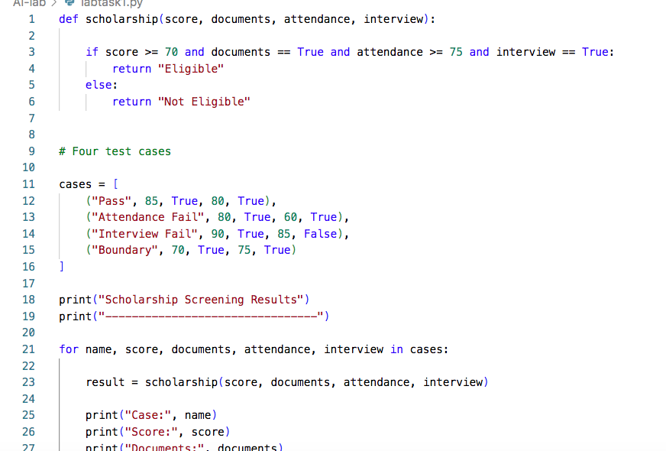etup.
Figure 3: Expected sample output for t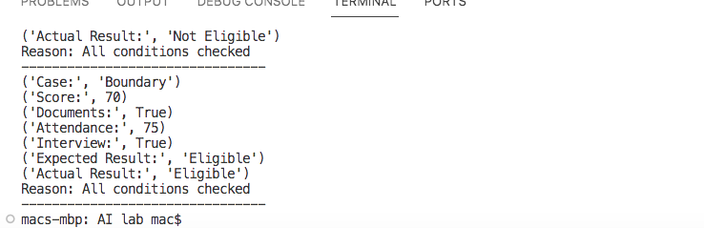he four test cases.

SUPERIOR UNIVERSITY
Artificial Intelligence Lab
LAB 1 – TASK 3
Student Name | Amina Mustafa
Roll Number | 329
Task 3: Conversational Test and General Intelligence
Introduction
A conversational test can show whether a computer system can produce responses that appear human-like during a conversation. However, passing such a test does not prove that the system has general intelligence. A system may communicate fluently while still misunderstanding facts, ignoring important conditions, or making incorrect decisions.
What the Conversational Test Observes
The Turing Test, introduced by Alan Turing in 1950 as the imitation game, focuses on whether a human judge can distinguish a machine from a human through written conversation. It observes the quality and human-like nature of the system’s conversational responses.
What It Does Not Establish
A successful conversation does not by itself establish that a system understands the world, reasons correctly in every situation, learns independently, or performs different real-world tasks reliably. It also does not prove that the system’s answers are accurate. Conversational ability is only one kind of performance and is not a complete measure of general intelligence.
Example from the Scholarship Screening Case
In the lab’s scholarship screening example, an application has a score of 91 but its documents are incomplete. The symbolic rule checks both conditions: the documents must be complete and the score must be at least 70. Therefore, it returns “Hold.” A probability threshold of 0.70 may return “Review” if the supplied probability is 0.88. An assistant might fluently explain that the high score means the student should be reviewed, but this reasoning is incorrect if it overlooks the missing documents. A convincing explanation is not enough; the system must also follow the stated requirements.
One Additional Test of Reliable Task Performance
A useful additional test is a rule-compliance test using a set of new scholarship applications, including complete applications, incomplete applications, low scores, and boundary scores. The system should be given the same documented criteria and its decisions should be checked against the expected results. The test should also include edge cases and report every incorrect decision. This checks whether the system performs the specific task consistently, rather than only whether it can talk convincingly.
Conclusion
The conversational test is useful for observing human-like conversation, but it cannot alone prove general intelligence or dependable decision-making. In the scholarship case, reliable performance requires checking the score and document-completeness conditions correctly. Therefore, conversational ability should be combined with practical tests of accuracy, consistency, and rule-following.
References
Turing, A. M. (1950). Computing Machinery and Intelligence. Mind, 59(236), 433–460. https://doi.org/10.1093/mind/LIX.236.433
Artificial Intelligence Lab Manual, Lab 1: Introduction to AI & Paradigms, Sections 1.5–1.7 and Lab Task 3.
Artificial Intelligence Lab | Amina Mustafa | Roll No. 329

